**How to Search the Internet & Email Proclamations**

By Barbara Sharp

1. Get a tablet / or / make yourself an Excel format with at least 8 column rows across the top.

Excel format Example:

|  |  |  |  |  |  |  |  |  |
| --- | --- | --- | --- | --- | --- | --- | --- | --- |
| **Date Emailed** | **City/Town/Village** | **Contacted Date** | **Contact person** | **Title** | **Phone** | **Address** | **Email & website** |  |

1. Set a Goal for yourself on how many places you would like to contact and get to know in your area.
2. Make a list of the Cities/Towns/Villages/Townships/Counties etc.… Once you have that done you will be ready to start your search. (All it really is, once you get used to it – you will be Copying and Pasting a lot, then maybe a few phone calls and go to a few boards meetings-if any)
3. **Web searches**—Example: **BELOW is** a search for the **“Mayor of Kankakee, IL”** (this is from my mobile phone-it is the only way I could save a picture to show you what comes up-desk computer or laptops might be different looking. I used Google)

As you can see on my mobile phone it shows the **official** **“Kankakee Mayors Office**” website connection and more information you will need once you make contact. Take Notes of their Phone/Address/hours of operation/website link. **CLICK** on Their **WEBSITE Link**

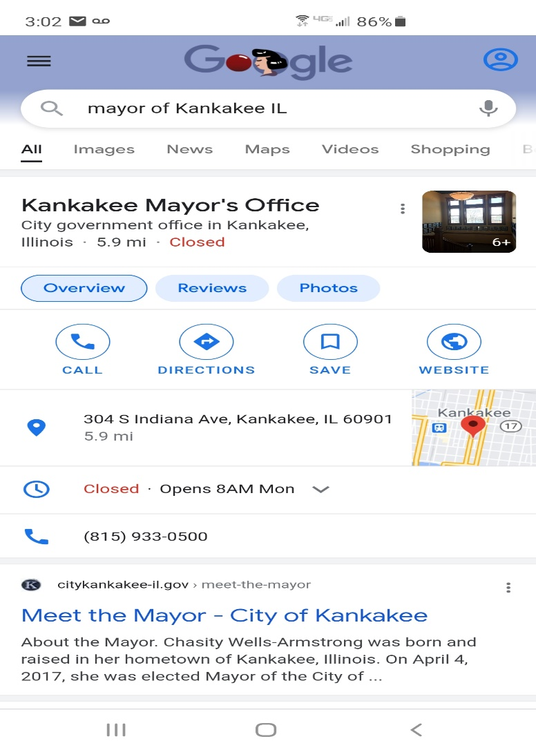

Another Example of how they can look from searches, just make sure the link you click on

is the **official website** and Not a “AD “link.

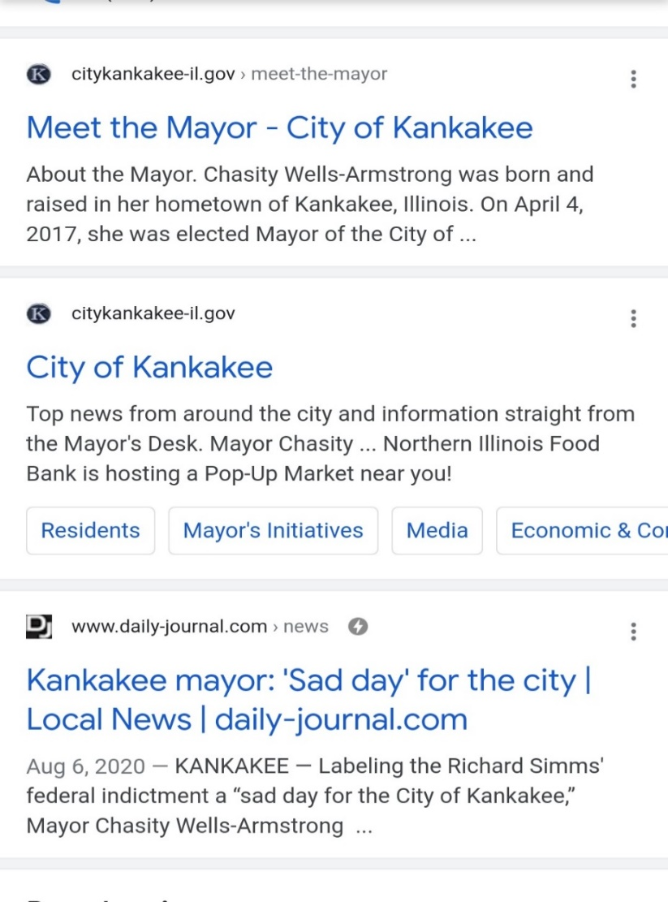

Once you have the official website, start clicking on the link and it should come up with all their information: departments, committee members, board meeting dates, government, and staff information’s, etc.

Start searching their website for “Government” or “Staff “contacts. Look at Example Below

* **Start doing your searches in February or March, so You can begin to email them ASAP in April. May comes fast and I will tell you this, they Will have their upcoming board meetings booked in months in advance. So, try to start early and get the requests out early. Sooner the Better-Doesn’t hurt.**

1. **Below** are pictures of Kankakee, Illinois Web addresses. Their phone number is right at the top of page along with a link to ask a question. Usually that link goes to the head Clerk, sometimes they will get back to you but don’t count on it. In picture **A** you will see the link for the Government which I already clicked on and it displays more links.

What you are looking for is the Head Clerk and the Mayor’s Direct email information.

In Picture **B** is the Mayor’s email address, name, address, phone number, fax-Write it ALL DOWN (make sure you get the correct Mayor-especially when its election time-it can change)

A.

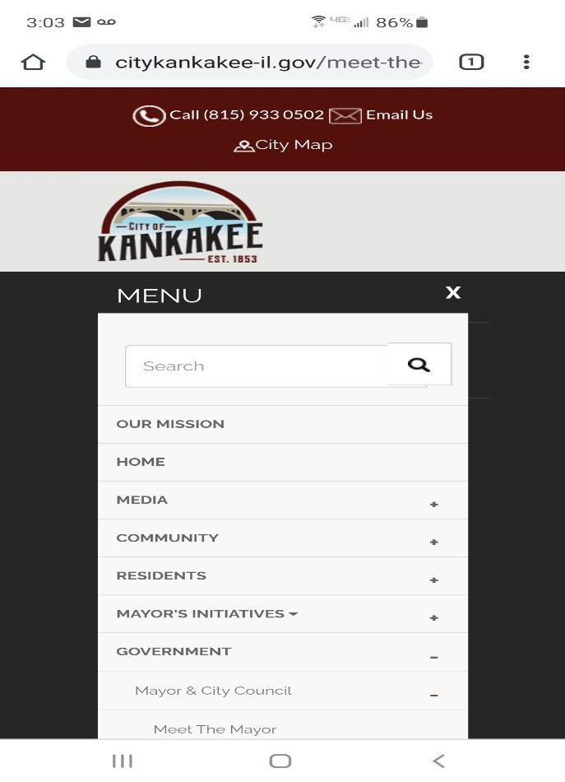

B.

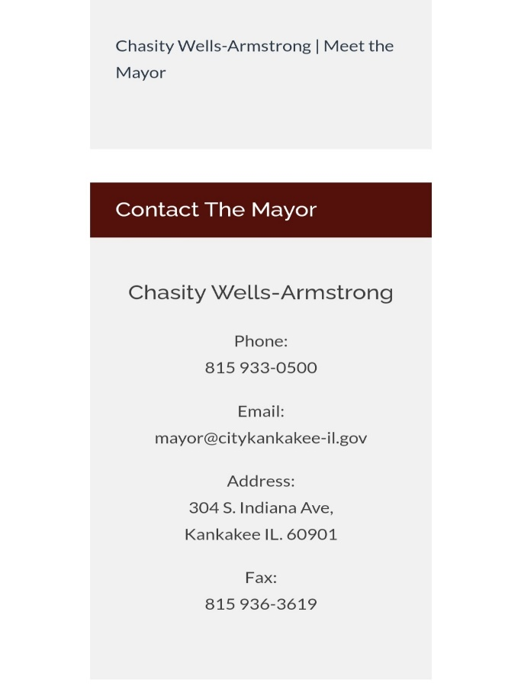

1. The Picture is with the City Clerk, she is the HEAD CLERK, sometimes they are called Administration Clerk. Please make sure you get their Position correct when you talk to them.

They can be a little cranky. As you can see, the city clerk information is on the link as well. Sometimes

If there is an email link under their picture-just click on it and it will pull up their email address-copy it down to your notes.

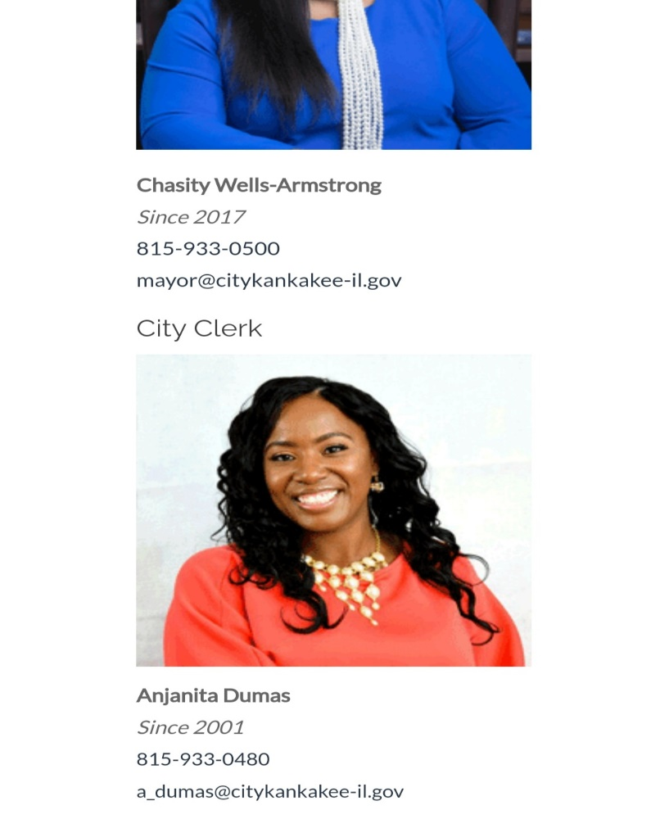

**Just a little NOTE**: What I did with the information. I scrolled over the information, 1 at a time like their email address and I highlight and copied it-then pasted it to my Excel format (less typing for me, lol). I do this for everything, that way I know all the information is correct.

NOW you can search for ALL your Cities/Towns/Villages/Counties this way. You can look up Mayors/ Presidents/City Clerks/ Clerks/Council members.

Examples again for looking up, put in the search subject line: **Mayor Town state** and push search—BOOM there you go. I also normally have more than website and folder open at a time n (I multitask). Once you get the hang of it, I know you can do better every year after.

**Next Steps-How to Email Proclamations**

1. To email the president/mayor AND clerk, you need to mail them in the same email (not separate). Usually, the clerk will open the emails first and send it or take it to the mayor/president. They are the go-to person-make sure you get their position correct if you talk with them personally.
2. Next, **COPY & PASTE** (OR) **type the information in for both** mayor and clerks email addresses on the SEND TO line, if you have more than 2 people, that is okay-someone will respond to you.

**Example 1 below**:

You see my email address is on the line FROM and the MAYORs email address on the line TO.

On the SUBJECT line, you see the “PROCLAMATION REQUEST” typed in.

THIS is done to EVERY email I send out.

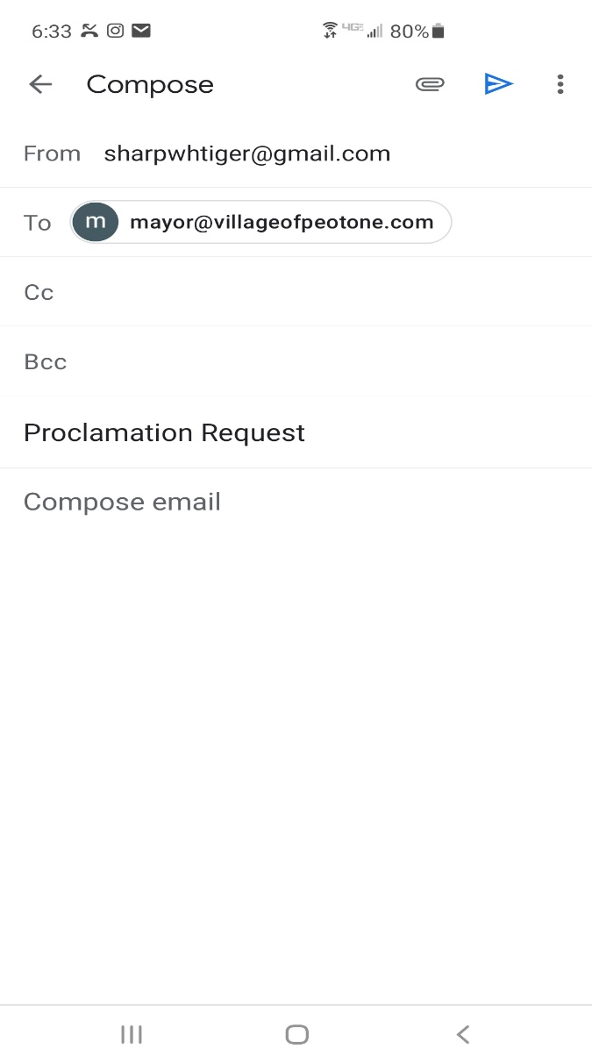

**Example 2 below:** You can see more information in this **drafted email**, and DON’T FORGET to put your name and contact information in the email too. Also **ADD** GWRRA/ your Districts website and if you have a chapter link—POST it in your email so they can click the links and learn how we are and what we do.

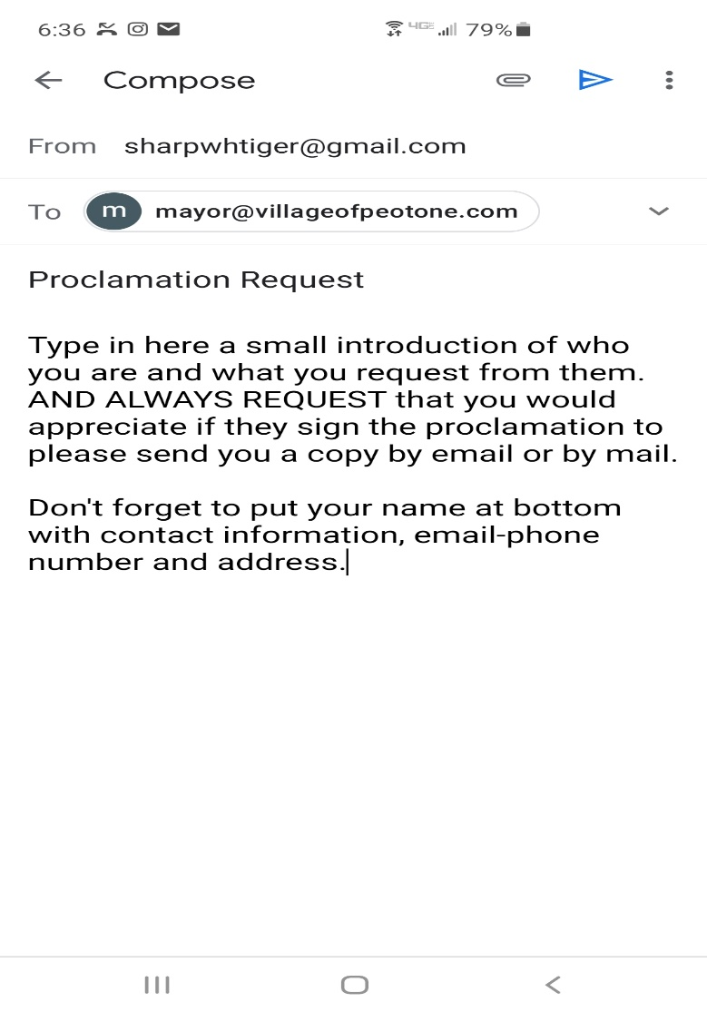

**NOTE:**

Once you get the hang of copying and pasting emails and the summary information, you will find out its not as hard as it looks.

**Example of Introduction I put in a few emails:**

I do hope all is well with you, your family, and your staff during these trying times of coronavirus. GWRRA is still promoting safe driving (if they need to go out) along with being safe at home.

I have attached our Proclamation and Cover letter to this email in hopes that you support our cause to be responsible on sharing the roads and being safe.  We would like you to declare again that May is Motorcycle Awareness month. Let us work together in the community and learn from each other how to be safe at home and on the roads.

1. Next don’t forget to ATTACH Proclamation and THE COVER letter.

The “**paper clip icon”** is the attachment link. **THEN SEND YOUR EMAIL!**

**NOTE:**

Please look over your cover letter and the Proclamation BEFORE you email them—**MAKE SURE the dates are correct on them EVERY YEAR.**  And the proclamation letter has the year written in. Just double check that every year and save it on your computer.

1. Once you email the clerks and mayors/presidents; wait for a week or two to give them a call to ask them if they received your email of the proclamation for motorcycle awareness for the month of May.

If they haven’t received it-ask them if you have the correct email address, if not ask them for it.

Do not be afraid to ask the questions; also see if you need to be at their board meeting (either online/over the phone/ or in person) to get the proclamation. Plus ask them again if you can get a copy of the signed proclamation. ASK them when they will look at the proclamation and write that date down so you can check on it after that day.

1. When you receive the email back from the city/village/town; keep track who DID sign the proclamation, so you can send it again next year. ***Always Thank Them for their support on motorcycle awareness.***

Keep track (record of all your contacts) like I explain in #1.

*Get to know your newspaper editors, radio station personal, librarians, community commerce (etc.…) around your area, let them know what your organization does and why it is so important to let people know about motorcycle awareness.

1. A little extra acknowledgement goes along way for the ones who signed the proclamation; you can notify their local newspapers/radio stations etc. and give them a copy of the proclamation so they can post it or read it on air. They love to get recognition especially if its election year.

I hope this helps to get more Proclamation Signed for Motorcycle Awareness in the month of May.

THANK YOU FOR HELPING ALL OF US THAT RIDE.